Crookwell Uniting Church

“To Know Christ and Make Christ Known”
  - 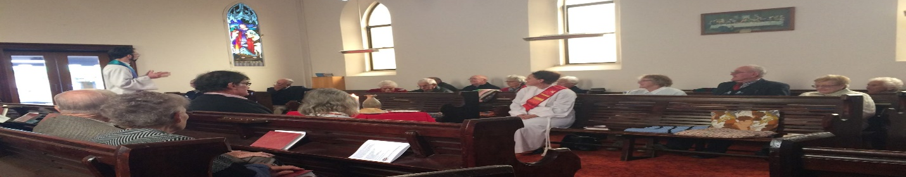Witnessing to God’s love for the world
  - From the main street to the paddock.

  - October 2023

A Busy Month Ahead: AGM Season

The days are getting longer. The air is warming up. That can only mean one thing: its AGM season again!

This October will be a busy month for our congregation. From 11 October to 3 November, Crookwell High School will be hiring our hall and kindergarten room for their HSC exams. Coul I therefore ask people not to enter the Hall between Mondays and Fridays without first checking with myself or Matthew if there is an exam on that day.

The sale of Kialla is progressing, and at the time of writing, we are hoping for an auction date in late October.
Speaking of sales – last financial year we sold Bigga. The money from that sale is now in a special ‘Proceeds of Sales account’ ready to be used for the capital on our childcare project. Unfortunately, that sale will also show as a ‘Capital Loss’ on our 2022-23 Annual Reports. Let me explain.

The Uniting Church insists that we list our properties on our balance sheet for their insured value. As this value includes complete demolition and rebuild, the insured value is often much greater than the market value of the property. That means, when we sell a property (such as Bigga or Kialla), we are selling it for much less than the insured value on our balance sheet. Consequently, the sale (though actually moving capital from property into cash) shows as a capital loss on our Profit and Loss statement. There is no way to avoid this under Uniting Church policy. That means, when you receive your annual reports, you will see a scary loss of a couple of hundred thousand dollars for 2023. Don’t worry! It is not an operating loss, but an accounting reality.

This year’s congregational AGM will be held after worship in Sunday 29 October in Crookwell. Annual Reports are due to Matthew by 15 October and will be distributed one week before the AGM.

I will be on leave from 25 September – 8 October, and I thank Barry and Adult Fellowship for leading worship while I’m away. Looking forward, please note our next joint service with St Bart’s will be on Sunday 5 November at the Anglican Church.

Daniel

____________________________________

Worship & Readings
Sunday 1 October
9:30am Crookwell and crookwelluniting.org

Readings: Exodus 17:1-7; Psalm 78:1-4, 12-16; Philippians 2:1-13; Matthew 21:23-32

Sunday 8 October
9:30am Crookwell and crookwelluniting.org

Readings: Exodus 20:1-4, 7-9, 12-20; Psalm 19; Philippians 3:4-14; Matthew 21:33-46

Sunday 15 October
9:30am Crookwell and crookwelluniting.org
2:00pm Jerrara

Readings: Exodus 32:1-14; Psalm 106:1-6, 19-23; Philippians 4:1-9; Matthew 22:1-14

Sunday 22 October
9:30 Crookwell and crookwelluniting.org

Readings: Exodus 133:12-23; Psalm 99; 1 Thessalonians 1:10; Matthew 22:15-22

Sunday 29 October
9:30 Crookwell and
Crookwelluniting.org

Readings: Deuteronomy 34:1-12; Psalm 90:1-6, 13-17; 1 Thessalonians 2:1-8; Matthew 22:34-46

Call For Leaders
We would like to put a call out for some more lay worship leaders for weeks when Daniel is not available. For this coming quarter, that means we are looking for volunteers to lead services on 26 November. Resources and training are available, including prayers, sermon preparation, video sermons and music. Please contact Daniel if you are interested.

October Roster
Please find below the roster for October services. If you would like to volunteer for future services, please contact Daniel.
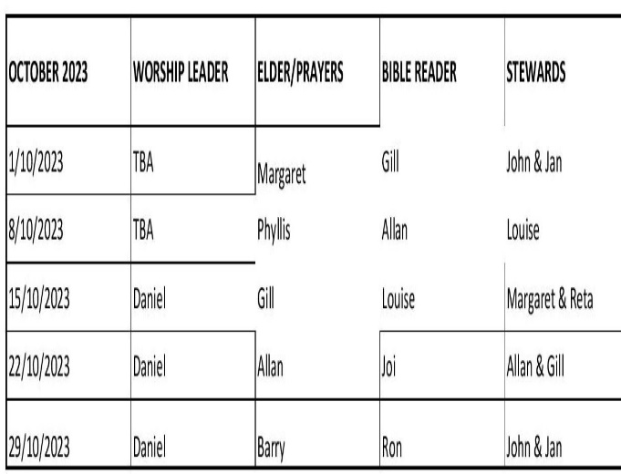

Meeting the Uniting Church Again for the First Time
The Uniting Church has a commitment to share our hope in the Gospel with our communities through worship, witness and service. We have designed Future Directions for the People of God on the Way to enable the growth of the Church’s witness to Jesus Christin by providing greater resources and renewing commitments, including:
- Reimaging ministry in and with rural and regional areas
- Reaching and empowering people in the first third of their lives
- Walking Together with First Peoples
- Acting and advocating for climate justice
- Working with Presbyteries across the Synod to stimulate growth in and through our congreagations.
For more details on Future Directions, please visit https://www.nswact.uca.org.au/media/1nwgcz5c/fd-impact-at-a-glance-final_app.pdf

If you would like a paper copy of this document, please let Matthew know.

