Crookwell Uniting Church

“To Know Christ and Make Christ Known”
  - 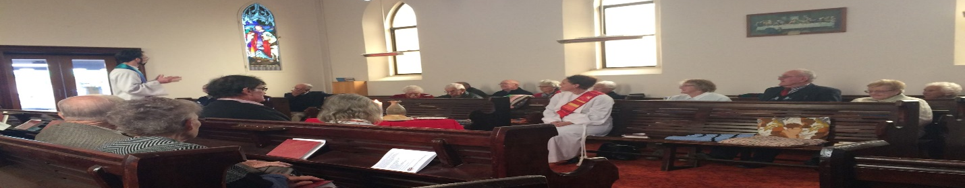Witnessing to God’s love for the world
  - From the main street to the paddock.

  - December 2021

A Child Among Us

During our online worship in September, we heard a reading from Mark’s Gospel in which Jesus put a child amid his disciples and said the words ‘Whoever welcomes one such child in my name welcomes me, and whoever welcomes me welcomes not me but the one who sent me.’ (Mark 9:30-37)

Since that time, we have wondered together what it means to welcome the children Jesus has put among us. As such, every Sunday we have prayed for the children in our lives (those in worship, those in playgroup, and those in our own families).

Well, it seems that God was listening to those prayers.

A few weeks ago, Barry and I were approached by Upper Lachlan Shire Council, who wondered whether we might consider making the space at the back of our church building (the hall, playgroup room and backyard) available for a new childcare facility.

It turns out that Crookwell (indeed our whole region) has a huge shortage of childcare placements available (one estimate is that Crookwell might be short of at least 60 places!).

Church Council discussed this concept just over a week ago and was keen to explore the possibility further.

Now, we are flagging it with you for conversation. At this Sunday’s AGM (December 5th) we hope to make some to time to discuss the idea further.

Here are some cliff notes for you to know:

- We have been approached by a private Childcare provider who would run the service and lease the space from the Church. For commercial in confidence reasons, we will not be naming that provider at this time.
- That provider has made us aware of what kind of works might need doing to bring the facilities up to standard, and has made us an offer about paying for a number of these works themselves.
- Council has offered to help us find other sources of funding for other possible works.
- Any lease or shared deal will need sign off by Synod before it could go ahead.
- At this time, no final decision has been made. Church Council has agreed only to explore the option further.

Whether or not this idea happens, it does serve as a helpful introduction to Christmas this year.

For Jesus not only put children in our midst – Jesus comes to us as a child. A child who demands to be cared for. A child who demands to be heard. A child who demands to be loved.

‘Whoever welcomes one such child in my name welcomes me.’ Jesus says.

Ain’t that the Christmas truth.

- Daniel

Christmas Services
Christmas Eve, Friday December 24
Jerrara 7pm

Christmas Day, Saturday December 25
Crookwell 9am

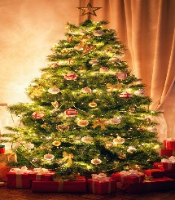

Worship & Readings

Sunday 5 December
9:00am Crookwell Wesley
crookwelluniting.org

Readings: Baruch 5:1-9; Luke 1:68-79; Philippians 1:3-11; Luke 3:1-6

Sunday 12 December
9:00am Crookwell Wesley

Readings: Zephaniah 3:14-20; Isaiah 12:2-6; Philippians 4:4-7; Luke 3:7-18

Sunday 19 December
9:00am Crookwell Wesley
crookwelluniting.org
2:30pm Jerrara

Readings: Micah 5:2-5; Luke 46-55; Hebrews 10:5-10; Luke 39-45

Sunday 26 December
9:00 Crookwell Wesley

Readings: 1 Samuel 2:18-20, 26; Psalm 148; Colossians 3:12-17; Luke 2:41-52

Binda Carols Are Back
After a COVID-19 induced break last year, Binda Community Christmas Carols are back in 2021.
The Carols will be held on December 15th from 5:30pm. This year, the event will be ticketed to comply with the NSW government’s density limits. Tickets are free.
Tickets are available at https://www.eventbrite.co.uk/e/binda-community-carols-tickets-210309349927
The day will include a bbq to raise money for the local school, as well as Christmas photos for the kids.

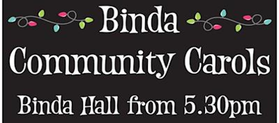

Christmas Bowl

Since 1949, compassionate Christians have contributed to the Christmas Bowl appeal, which provides safety for people in exile around the world.
The Christmas Bowl provides us with a practical way to show love for our neighbours most in need. Your gift to the Christmas Bowl will remind our neighbours around the world that they are not forgotten, that they are loved and that we are all part of God’s love. As we celebrate Christmas, may our love for our neighbour grow.
Envelopes for giving are available in the front foyer of the Church.

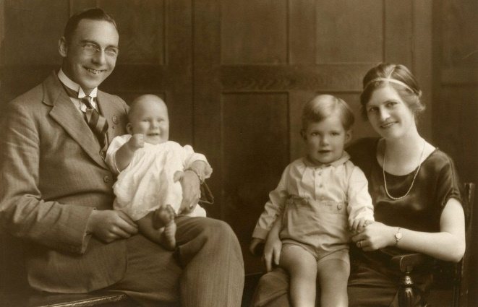
Rev. Frank Bryant was the catalyst behind the original Christmas Bowl in 1949

Kids’ Christmas Word Search

