Crookwell Uniting Church
  - 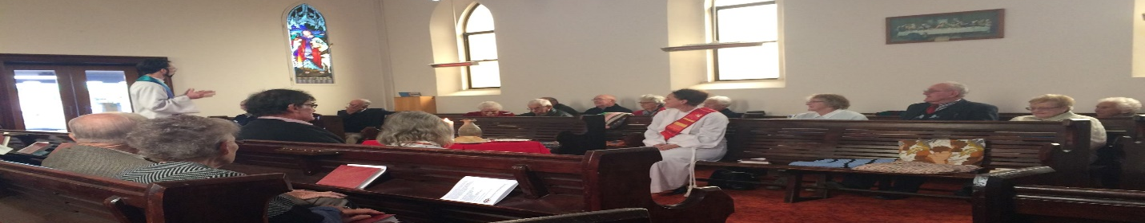Crookwell – Wheeo – Jerrara – Bigga – Kialla
  - September 2018

Minister’s Reflections
Vision, Principles, Mission

When we visited Iona in Scotland last year, Nicki, Benji, my in-laws and I decided to climb Dun-I. Dun-I is the tallest point on the island of Iona, at 101m above sea level. On a clear day, you can see all the way to Ireland from the top. Even though we knew the walk would be hard (I had to carry Benji most of the way), we really believed that the top would be worthwhile for the views, the sense of peace and quiet, and because many pilgrims had been here before us as part of their faith journey.

As we reached the point of starting the climb, we could vaguely make out a stone cairn that sits at the top of the mountain. Because the paths that climb the mountain often wind back and forth, this stone cairn served as a point of reference: at any time, we could look up to

check where we were headed and see how far we had come.

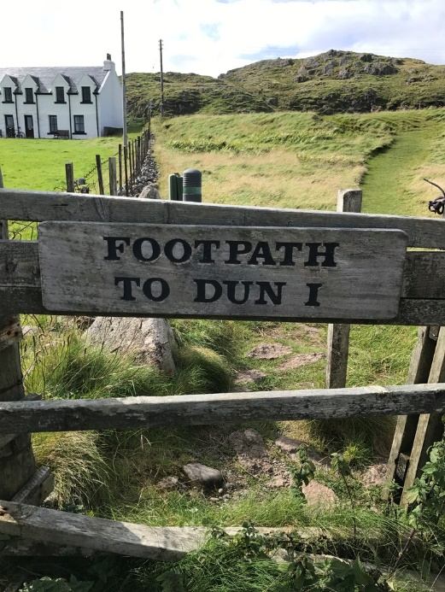

So, we started up the path marked ‘to Dun-I’. It wasn’t long, however, before we discovered that this one path split into many, many tracks, all leading to the top of the mountain; but with none standing out as obviously the best. Some climbed more gently but had huge patches of slippery mud. Others were drier, but at a very steep incline.

Figuring out which path to take was often difficult. An important thing was knowing ourselves and what we would be able to do as a group. Climbing with Benji often meant I had to pick a different path to what I might have if it was just me.

But we picked what we thought was the best path, and we just started walking. Occasionally we would find we had hit a dead end and had to go back. Other times, a new path opened, and we would change course. We had to continually respond to what we found in front of us, and had a few slips and falls on the way, but the stone cairn at the top continued to orient us.

We had a vision of where we were going (the stone cairn), that we could use to adjust our bearings as needed. We had a reason for making the journey: our underlying belief which told us that it would be worthwhile. We knew who we were as a group, and which way to the top would best match us. We then had to decide which path we needed to take first (acknowledging that along the way we would have to change path and direction several

times, depending on what we encountered). And then we had to take the first step.

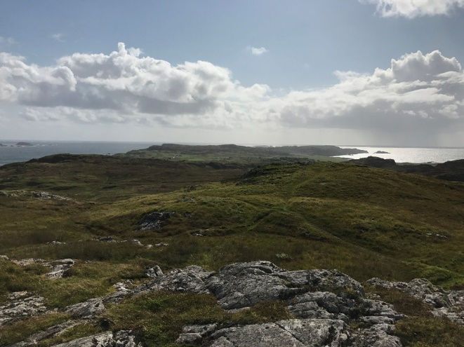

As a congregation, we too are on a journey. And, these steps outlined above can be helpful for us as we think about the pilgrimage of faith we are on:

We need a VISION (like the stone cairn on the mountain): a point of reference to remind us where God is calling us, so we can keep our bearings.

We need to acknowledge our guiding PRINCIPLES: the underlying reason we are taking the journey we are on, so that when we get tired and work out, we remember why we started in the first place.

We need a MISSION: an acknowledgement of who we are, where we are, and why we exist, so we can determine the path best suited to us as a congregation.

We need PRIORITIES: a decision about which path to take first, whilst acknowledging that no one path is perfect.

And then we too need to step out in faith.

In our National Church Life Survey results last year, the top thing people said they wanted given priority over the next twelve months was articulating a clear vision. So, between now and Advent, we are going to do just that.

We will seek to articulate our VISION, PRINCIPLES and MISSION, so we can make some decisions about what our PRIORITIES need to be in the next two years, and the next steps for us to take.

There will be more information in coming weeks and months about how we go about this exactly (Church Council and I still need to do some work figuring this out). During this time, however, I would invite you all to deep prayer for our congregation, listening for what God might be saying to us.

Because, God is doing something here in Crookwell. Of that, I am certain. There are signs of new life all around, and every day I am blessed to hear the stories of members of our congregation and our community. And it energizes me for the climb.

Last year on Dun-I, we did eventually reach the top of that mountain. The climb was exhausting. I fell over and got a giant mud stain on my backside. But the view we found at the top was breathtaking. And, there was one small moment that made that whole climb worth it: when Benji suddenly looked up at me, after having been carried the whole way, and declared “we did it Daddy!”

I wonder if when we too reach our destination, God will feel the same way I did in that moment.

Daniel

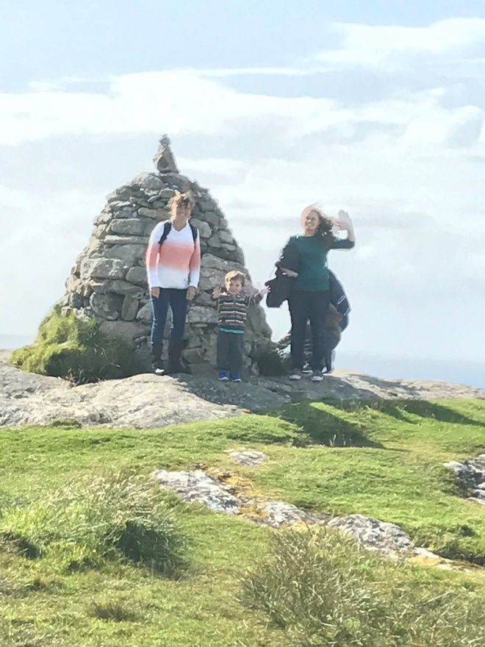

Worship & Readings
Sunday 2 September
9:00 Wesley
2:30 Wheeo
Readings: Song of Solomon 2:8-13; Psalm 45:1-2, 6-9; James 1:17-27; Mark 7:1-8, 14-15, 21-23

Sunday 9 September
9:00 Wesley (Holy Communion)
2:30 Jerrara
Readings: Proverbs 22:1-2, 8-9, 22-23; Psalm 125; James 2:1-10, (11-13), 14-17; Mark 7:24-37

Sunday 16 September
9:00 Wesley (Baptism)
Readings: Proverbs 1:20-33; Psalm 19; James 3:1-12; Mark 8:27-38

Sunday 23 September
9:00 Wesley
2:30 Bigga
Readings: Proverbs 21:10-31; Psalm 1; James 3:13-4:3, 7-8a; Mark 9:30-37

Sunday 30 September
9:00 Wesley
2:30 Kialla Pilgrimage
Readings: Esther 7:1-6, 9-10; 9:20-22; Psalm 124; James 5:13-20; Mark 9:38-50

Pastoral Partners
This year, Pastoral Partners will gather for mutual support and training on the following dates:
Friday 19 October, 3pm
Friday 14 December, 3pm
Please put these dates in your diary now!
If you are not already a Pastoral Partner but feel like God might be calling you to this ministry (even if you don’t feel ‘skilled’ enough), could you please come and speak to Daniel.

Save the Date: 20 September
The next Church Council meeting will be held on Thursday, September 20 at 3pm. Venue to be confirmed to all members before this date.
_______________________________________

Viewhaven Service
On the second Tuesday of each month at 10.30am, members of our church lead a worship service at Viewhaven. We could always do with volunteers at this service to help residents find their pages in their hymn books and other non-speaking roles.
If you are available to help, the next Viewhaven service will be Tuesday 11 September, 10:30am

Workshop

Congregation office bearers, Church councillors and Ministers in Placement are invited to attend a workshop designed to assist in contributing to the health of their congregation.

“The Church Guide for Making Decisions Together” will be held at the Yarralumla Uniting Church in Denman Street, between 10am and 4pm on Tuesday, 9 October. Cost is $30.

RSVP Terence Corkin before September 15 via email: office@cruc.org.au

A Thought for our Farmers

While the NSW Government’s drought relief package is most welcome, there is no substitute for a generous dose of rain. Let’s keep the farmers in our thoughts and prayers.

ISAIAH 30:23

He will also send you rain for the seed you sow in the ground, and the food that comes from the land will be rich and plentiful. In that day your cattle will graze in broad meadows.

Meet our new administration assistant
Crookwell Uniting welcomes new administration assistant, Matthew Geddes to our team. Matthew is perhaps best known in the local community as an author of several historical sports books, and for his sports reports every week on 2GN.

A resident of Crookwell since 2013, Matthew brings the experience of several years working for Misison Australia in employment and communtiy services. He has worked extensively with youth, Aborginal Australians, parents returning to work, and the long term unemployed in Sydney, Lithgow, Mudgee, Wollongong, Nowra, Wyong, and Goulburn.

Matthew will be working from Wesley in Crookwell on Mondays and Tuesdays between 9am and 1pm.

Playgroup
All preschool children are welcome to attend Playgroup at Wesley, every Tuesday from 10:30am during school terms.

Children participate in indoor and outdoor play, and craft activites. Morning tea is provided.

For more information, please call Aimee Kent on 0418 216 028.

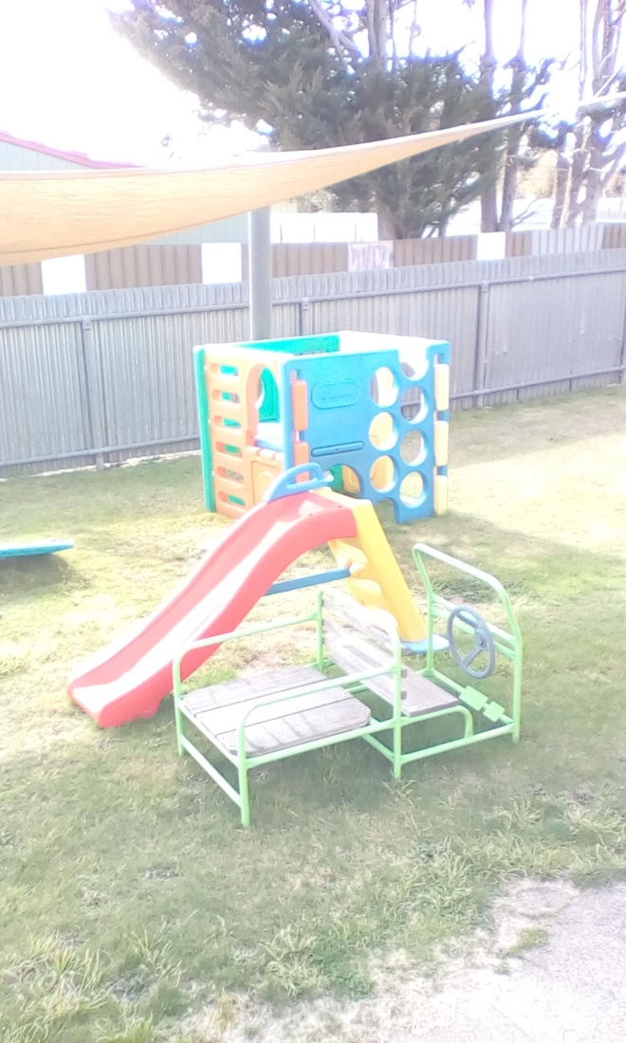

Bookshop News

The Christian Bookshop, at 50 Goulburn Street in Crookwell has new stock, including children’s books, titles by Australian authors, and fair trade gifts and products.

Come and see Heather and her team of volunteers, and buy a gift for someone you love; or just a treat for yourself!

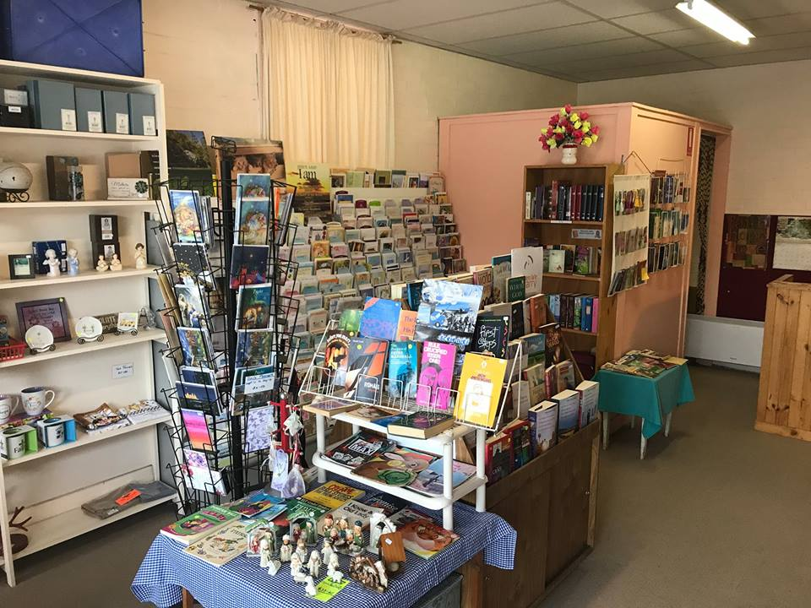

Save the Date: September 30
The Fifth Sunday lunch is back at Wesley on September 30 at 12pm. Everyone is invited to attend. Please contact Daniel on 0432 648 676 for further information.

